College Library

Management System

Index
- Introduction

- High-Level Design

  - System Requirements
  - Proposed System
  - Modules
  - Hardware and Software Specification
  - Actors in the System
  - System Architecture of Library Management System

- Low-Level Design

  - Use Case Diagram
  - Class Diagram
  - Entity Relationship Diagram
  - Activity Diagram
4. Conclusion

Design a College Library Management System

Introduction

A College Library Management System is a software built to perform housekeeping functions of a library. Library management system helps libraries to keep track of books and their checkouts as well as the member’s profile.

Library management system also involve maintaining a database for entering new books and users. It also storing the books that have been borrowed with their respective due date, fine and book limit.

High Level Design

System Requirements

- Any library member should be able to search books by their title, author, and category with a keyword
- Each book will have unique identification number and there could be more than one copy of a book
- Each member will have unique id and password to login
- Members are categorized based on their role (student, librarian, admin)
- Students can only search for a book and access their account details (books they borrowed with due date, fine and status)
- Members can checkout maximum limit of 3 books
- There should be a maximum limit (15) days a member can keep a book.
- The System should be able to keep track of fine, due date and book limit.
- For each overdue date Rs.10 will be added in fine.
- When a member checked out a book, no of copies will be deducted
- Librarian can issue book, add, delete, and update book details, view issued books and books list.
- Admins have all the access including adding new member, updating, and deleting the member profile

Proposed System:

- The proposed system includes the following features:
- User-friendly interface
- Fast access to the database
- Search facility
- Quick transactions
- Database maintenance for user and book details
- Librarians can perform all book-related operations
- Admin has full access, including member registration and cancellation

Modules

The system consists of the following modules:
- Admin Module: Operated by the admin with a unique ID and password. The admin manages authentication, authorization, and can assign new admins, librarians, and students.
- Librarian Module: Used by library staff to enter records, manage book-related activities, and check book availability.
- Student Login Module: Allows students to search the catalog and view their account details.
Hardware and Software Specifications:

Hardware:
- Processor:MacOS
- Hard Disk Space:40GB
- RAM:256MB

Software:
- Operating System:
- Browsers: All industry-standard browsers
- Front-End: HTML, CSS, JavaScript, JSP
- Back-End: Java, Spring MVC, Spring Data JPA
- IDE: Spring Suite Tool, Eclipse with Spring Tool Plugin
- Database: MySQL

Actors in the system
We have 4 main Actors in this system
- Student: Search the catalog and view their account details
- Librarian: Mainly responsible for issuing, adding, and modifying books
- Admin: has all the access including adding new member, deleting, modifying existing member
- System: Mainly responsible for keep track of due date, fine, book limit, status of a book

System Architecture of Library management system
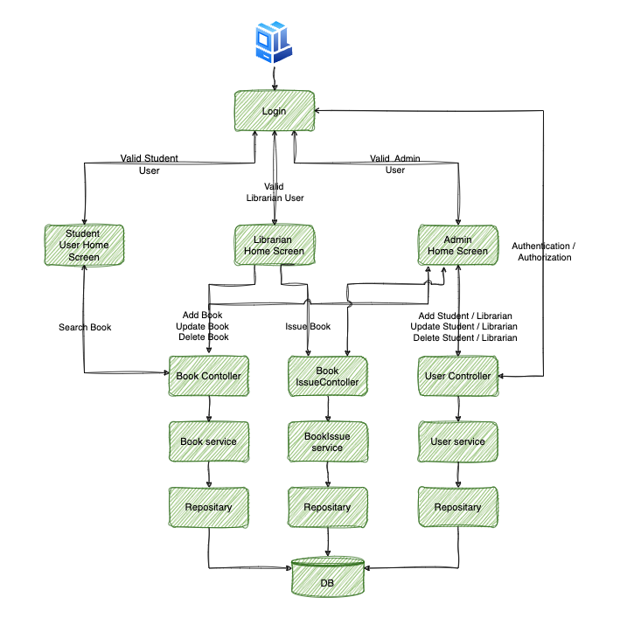

Low-Level Design

Use Case Diagram: Below are the main use cases of the Library management system

- Add/Remove/Edit book
- Issue book
- Add/Remove/Modify Member
- Search Catalog

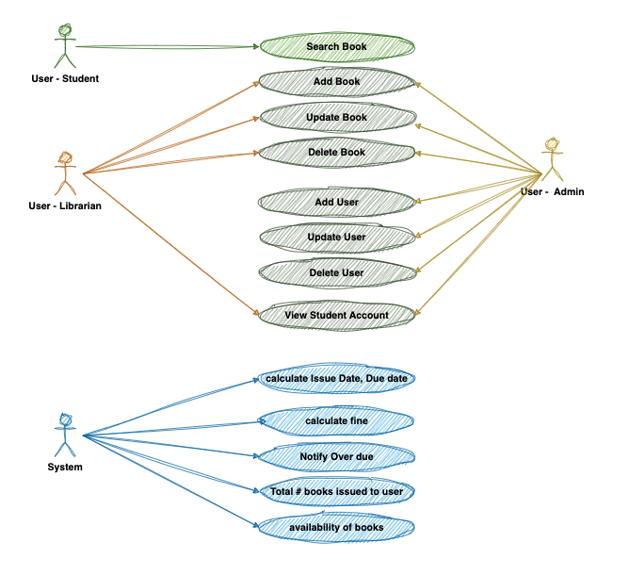
Here is the use case diagram of Library management system

Class Diagram

Here are the main classes of Library management system
- Book: The basic building block of the system. Every book will have unique Book-Id, Title, Author, Category, Publishers, etc.
- Login: Every member will have unique id and password to access their account based on their role
- Issued Books: Class will contain list of all books issued for the members
- Student: Every student will have a profile and its related account
- Librarian: Librarian has the access to view all the transactions and can do all book related operations
- Admin: Admin has access over all the area including registering a new/cancelling member

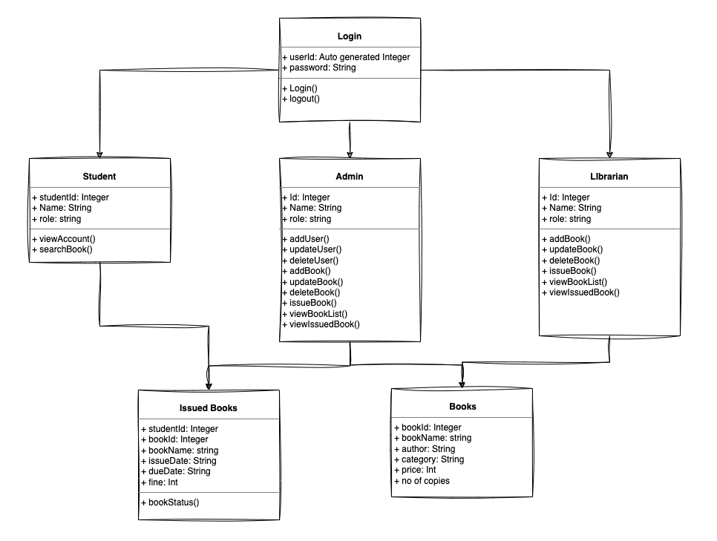

Entity Relationship Diagram

The library management system has 3 Tables

- Member/User: This table has the members name, role and unique Id and password for login
- Books: This table has book-related information like title, author, category, price, publisher, copies
- Books issued: Has all the transaction details of the members

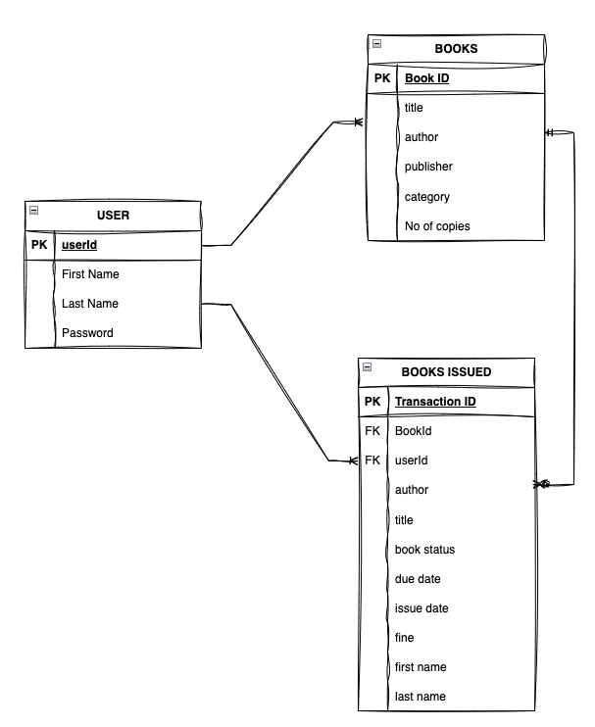

Activity Diagram

Each member will have an activity based on their role

Student Activity Diagram

- Login
- Search catalog
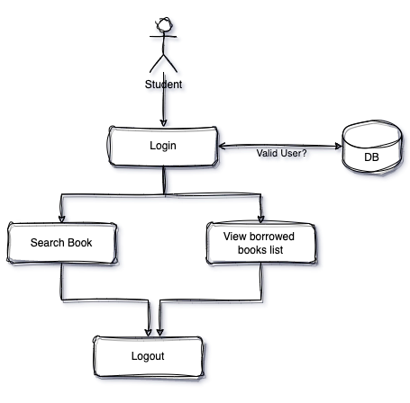
- View borrowed books
- Logout

Librarian Activity Diagram

- Login
- Add/Delete/Update book
- Issuebook
- View issuedbooks
- View books list
- Add/delete/update transaction
- Search catalog
- Logout
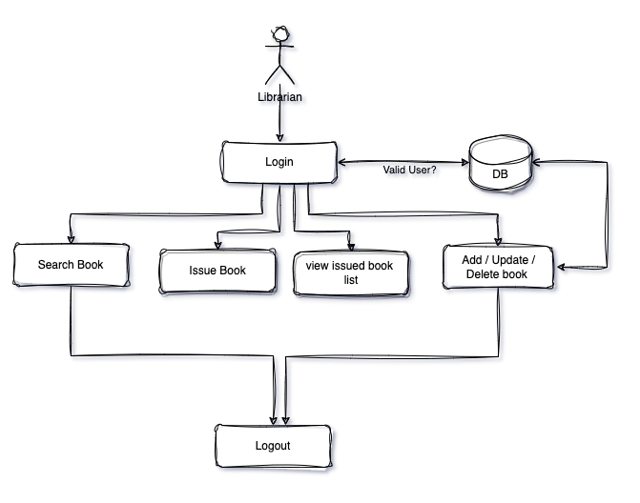

Admin Activity Diagram

- Login
- Add/Delete/Update book
- Issue book
- View issued books
- View books list
- Add/delete/update transaction
- Search catalog
- Add/update/cancel member
- View members list
- Logout

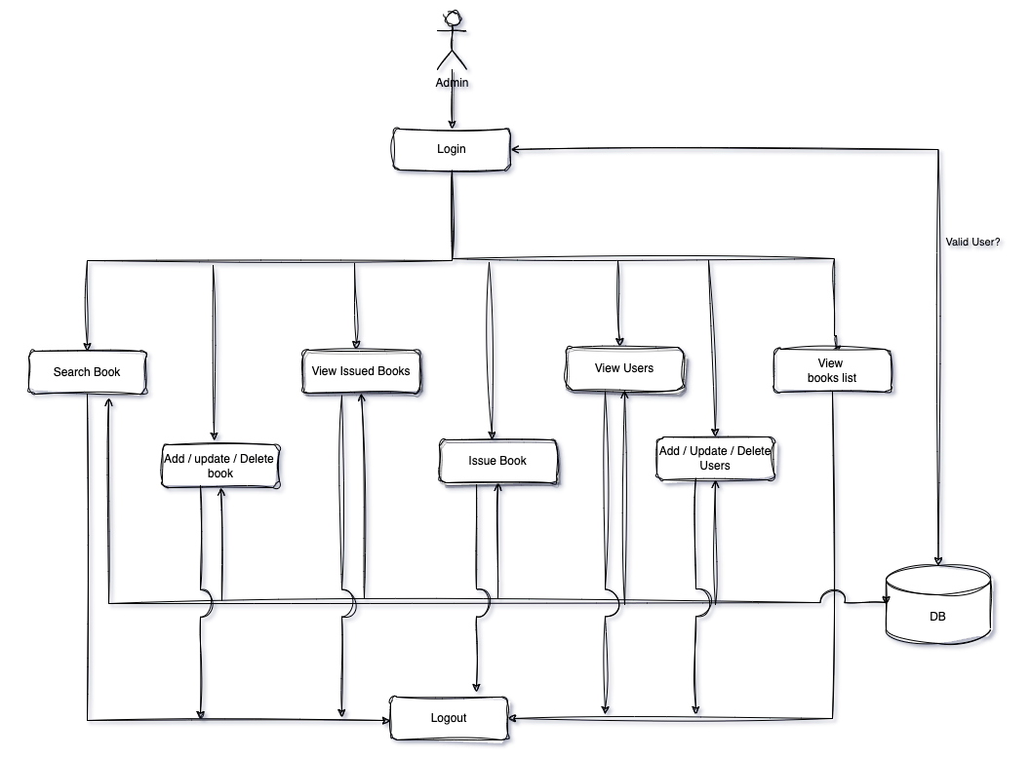

Conclusion:

In conclusion, the design of the College Library Management System encompasses various aspects necessary for efficient library operations. The system allows library members, including students, librarians, and administrators, to perform their respective roles effectively.

The system requirements outline vital functionalities such as book search, member login, role-based access, checkout limits, and refined tracking. These requirements ensure that library members can easily search for books, manage their accounts, and adhere to borrowing policies.

The proposed system offers several advantages, including a user-friendly interface, fast database access, search functionality, and quick transactions. It also maintains a comprehensive database for storing user and book details, allowing librarians to perform various book-related operations. Administrators have complete control over the system, enabling them to manage members and their profiles.

The system architecture illustrates the overall structure and interactions between different components of the library management system. The use case diagram showcases the system's main functionalities, while the class diagram highlights the essential classes and their relationships.
Furthermore, the entity relationship diagram represents the database structure, including tables for members, books, and book transactions. Lastly, the activity diagrams visually represent the actions performed by students, librarians, and administrators within the system.

The College Library Management System is designed to streamline library operations, enhance user experience, and efficiently manage books and member profiles. By incorporating the proposed system, the college library can improve its services and provide a seamless experience to its users.

